|  |
| --- |
| Use case name: Assign Employees To Shifts. |
| Textual Description: Process of assigning employee to shifts that take place in different times and different branches. |
| List of Actors: HR manager, Employee. |
| Pre-conditions: Employee and HR Manager are identified and authenticated. |
| Post-conditions: Shift exists (created), Employee is registered to it to a role he requested in it, while he is certified to do that role. Employee is registered to only one role. Employee is not registered to any other shift that happens at the same day. Employee is not registered to more than 6 shifts that week. Employee is part of the branch the shift takes place in. |
| Main success scenario:  1.HR manager certifies an employee to take part in certain roles.  2.HR manager creates a shift on a given date, time and branch, specifies it's needed roles and amount of each role.  3.Employee chooses his shifts out of the available choices that are relevant to him.  4.For each shift employee has to specify which role he wants to be, out of his available roles.  5.HR manager gets the employee's requests for shifts and roles and registers him accordingly. |
| Alternatives/Extensions:  3a. Employee already registered to a shift that day, registered to 6 shifts that week:   1. Request won't be sent.   4a. Employee chooses a role he is not certified to be:   1. Request won't be sent.   5a. HR manager tries to register an employee to a shift and/or role he had not requested:   1. Registration will fail, effect won't take place and a notice will be sent.   6. HR manager will verify the shift.  6a. Shift didn't reach the needed amount of employees in every needed role:   1. A warning notice will be sent. |

**1. B**

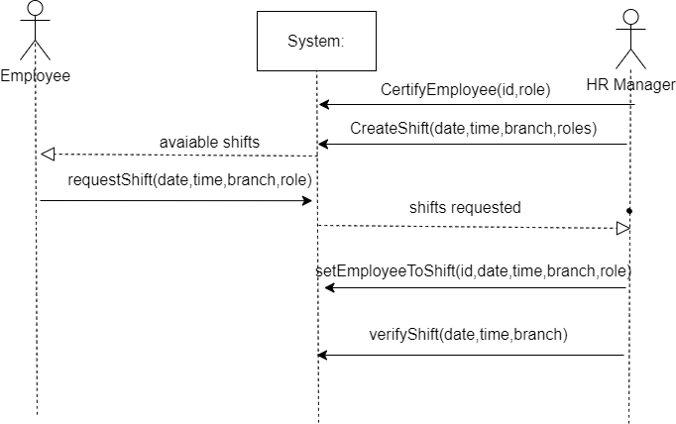

|  |
| --- |
| Use case name: Send A Transport |
| Textual Description: The transport manager received a transport document and entered to the system to create a new transport. |
| List of Actors: The transport manager |
| Pre-conditions:  1) The driver is free to make the transport on the given date  2) There is a supplier who is available to take the transport on the given date  3)The driver has the appropriate permissions to drive the truck  4) The truck is suitable for the given transport  5) All the drivers and details are exists in the system. |
| Post-conditions: 1) The transport was successfully created in the system. |
| Main success scenario:  The transport manager enters the system and creates a new transport while checking the following:  1) Is the driver free and able to carry out the transport  2) Will the stoke keeper will be able to collect the shipment from the destination  3) Does the driver have appropriate permissions for the given truck  4) The truck is suitable to carry out the transport  5) The transport weight will be suitable  the transport will created successfully. |
| Alternatives/Extensions:  1) The driver does not have appropriate permissions to drive the truck:  In that case there will be an option to choose a suitable new driver  2) The weight of the truck has exceeded the limit: in this case we can change the truck / change destinations.  3) There is no store keeper available to pick up the shipment: a message will pop up to the screen and transport creation will canceled  4) There are no drivers available on the given date:  A message will pop up to the screen and transport creation will canceled. |

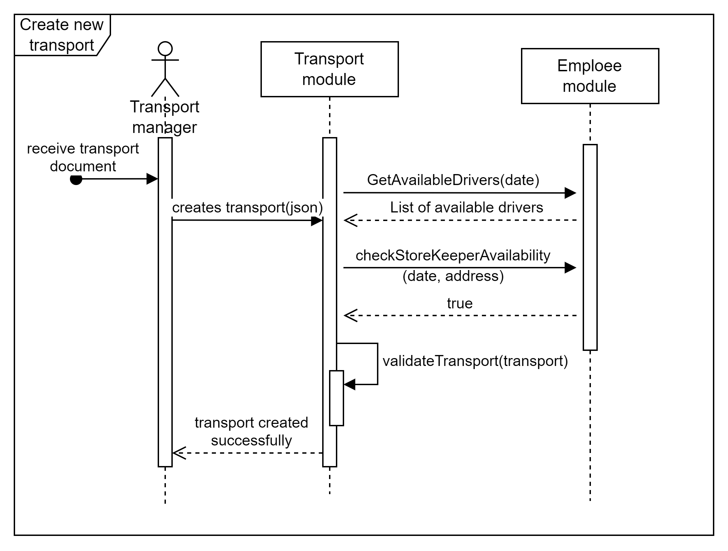

**.2.A**

**Scenario G**

**Contract 1: certifyEmployee (id,role)**

References: UseCases: Assign Employees To Shifts

Preconditions: Employee exists.

Postconditions: Employee's set of certifications is updated to have the mentioned role.

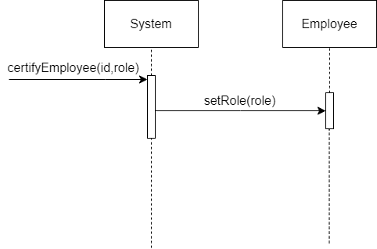

**Contract 2: createShift (date,time,branch,roles)**

References: UseCases: Assign Employees To Shifts

Preconditions: branch exists, shift is not created yet.

Postconditions: shift instance is created and initialized.

**Contract 3: requestShift (date,time,branch,role)**

References: UseCases: Assign Employees To Shifts

Preconditions:

1.Shift of the specified date, time and branch exists.

2.'role' is part of the shift's set of needed roles, employee is not registered to 6 or more shifts that week and not registered to a shift at all that date.

3.Employee exists and is certified to be that role.

Postconditions: Employee is associated with the mentioned shift, as a requesting employee.

**Contract 4: setEmployeeToShift (id,date,time,branch,role)**

References: UseCases: Assign Employees To Shifts

Preconditions: Employee is associated with the mentioned shift as a requesting employee, for the specified role.

Postconditions: Employee is associated with the shift as a registered employee for the specified role.

**Contract 5: verifyShift (date,time,branch)**

References: UseCases: Assign Employees To Shifts

Preconditions: shift exists.

Postconditions: shift's 'is verified' field is set to true.

**Scenario H**

**Contract 1: validateTransport (transport)**

References: UseCases: Create a transport

Preconditions: All the objects are exist in the system(driver, truck, item lists etc.)

Postconditions: The transport meets all the conditions and can be created successfully

The driver's license is appropriate, the weight of the truck is suitable, the driver is free that day for transportation and there will be a store keeper available to pick it up.

**Contract 2: GetAvailableDrivers(date)**

References: UseCases: Create a transport

Preconditions: The date included the correct time and date of the transport.

Postconditions: The returned list will only include the drivers who are available for transportation on the given date.

**Contract 3: checkStoreKeeperAvailability(date, address)**

References: UseCases: Create a transport

Preconditions: The date included the correct time and date of the transport and the address of the destination.

Postconditions: In the case of success nothing will be returned and in the case of an error a message will pop up to the screen informing that there is no free stoke keeper.

**Contract 3: createTransport(json)**

References: UseCases: Create a transport

Preconditions: The string contains all the details required to create a new transport (driver, truck, item lists etc.)

Postconditions: In the case of success the transport will created successfully and added to the system and in the case of an error a message will pop up to the screen informing the reason that preventing the creation.